Library Books System

The Library Book contains many functions, The most important of which enables The librarian has access to the System by:

* Username
* Password

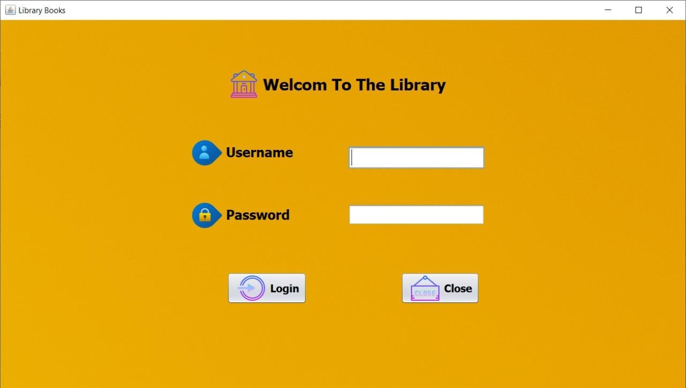

Then, After the entry, tap login to enter to system .

Then there are several other functions that meet the Librarian’s orders.

* Add New Books
* Add Members

1

* Borrow Books
* Logout

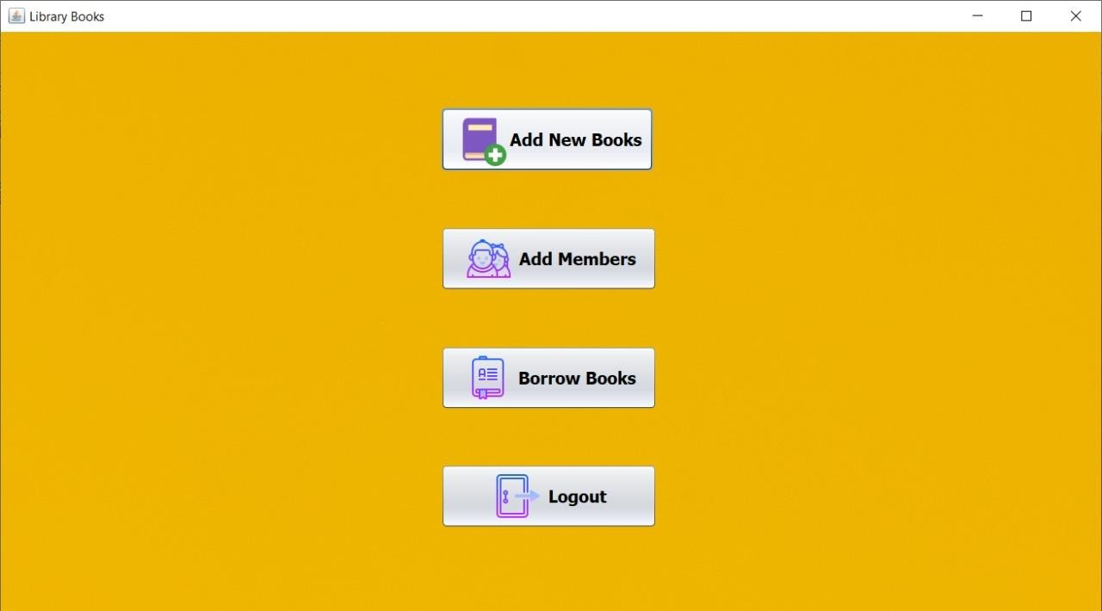

If the client need to add some books he must give the permission (**Add New Books**) that contains

* + Insert New Book
  + Update
  + Search By ID
  + Delete Book
  + Show All Books
  + Reset



2

The Librarian must perform these tasks to (**Insert New Book**):

* Book Name *Book Id

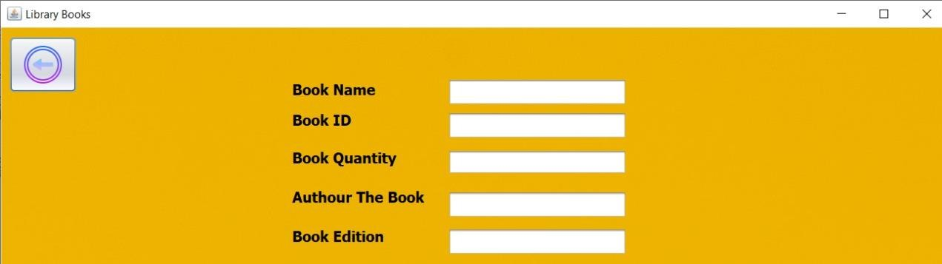* Book Quantity *Author Book *Book Edition

# Update :

The Librarian can tap update to show the commands that were added or removed in the system .

# Search By Id :

This function enables the Librarian, If he has the book Id, to search for and find the book.

# Delete Books :

3

This function enables the Librarian to delete the book he doesn’t want from the books stored with the Librarian.

# Show All Books :

Enable the Librarian to know which books are available in the library book .

# Reset :

It modifies, and repairs in a new way, and allows the Librarian to enter all data from the beginning in this system.

If the Librarian need to add Members he must give the permission (**Add Members**) that contains

* + Add Member
  + Update
  + Search By ID
  + Delete Member
  + Show All Members
  + 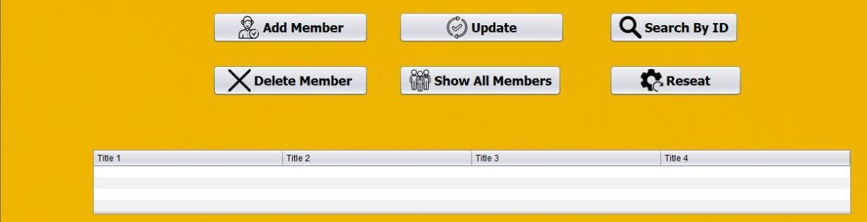Reset

4

The Librarian must perform these tasks to (Add Member) :

* Member Name
* Member ID
* Address
* Book Borrowed

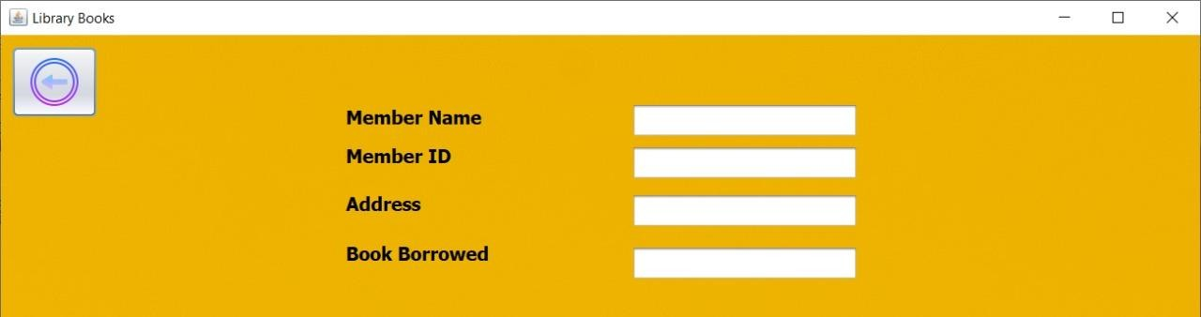

# Update :

The Librarian can tap update to show the commands that were added or removed in the system .

# Search By Id :

This function enables the Librarian, If he has the book Id, to search for and find the book.

**Delete Member :**This function enables the Librarian to delete any member from the stored data member.

5

# Show All Member :

This enables the Librarian to know the number of all the member that stored in system of library.

# Reset :

It modifies, and repairs in a new way, and allows the Librarian to enter all data from the beginning in this system.

If the Librarian need to Borrow Books he must give the permission (**Borrow Books**) that contains.

* Borrow Done
* Return Book
* Show All Data
* 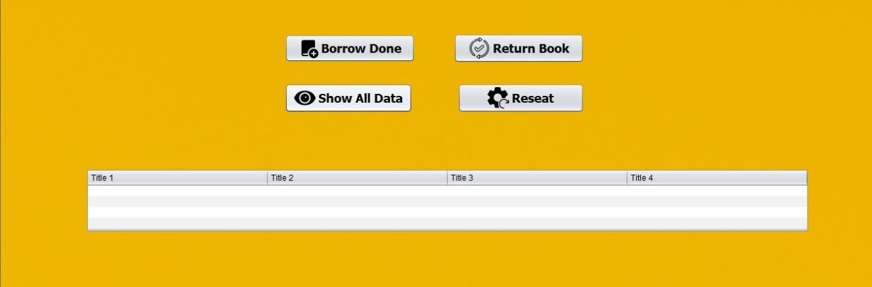Reset

The Librarian must perform these tasks to (Borrow Done ) :

* + Member Name
  + Member ID
  + Book Name
  + Book ID

6

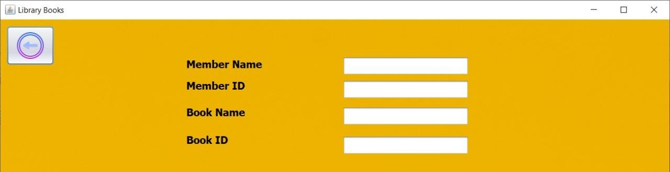

# Return Book :

It is for the Librarian to return , bring or send the books that he borrowed it before the specified period end.

# Show All Data :

It shows all the data on the borrowed books and their owners, and the books available for borrowing.

# Reset:

It modifies, and repairs in a new way, and allows the Librarian to enter all data from the beginning in this system and make default within data .

If the Librarian need to Logout he must give the permission (**Logout**) and it will exits the system.

7

**Team Members**

•علي محمد عبدالعزيز

•عبدالرحمن احمد محمد انور

•عمر حسن صبري

•محمد احمد طه

8